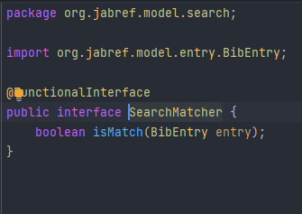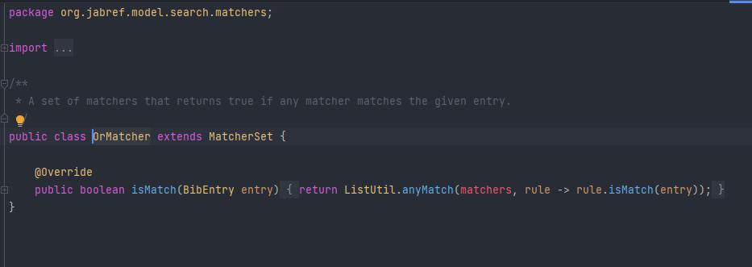

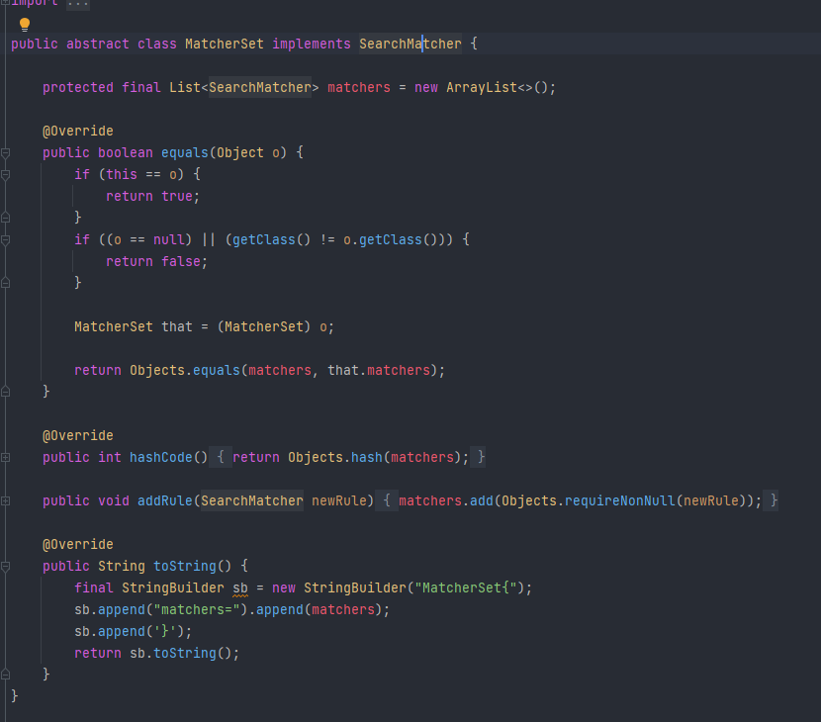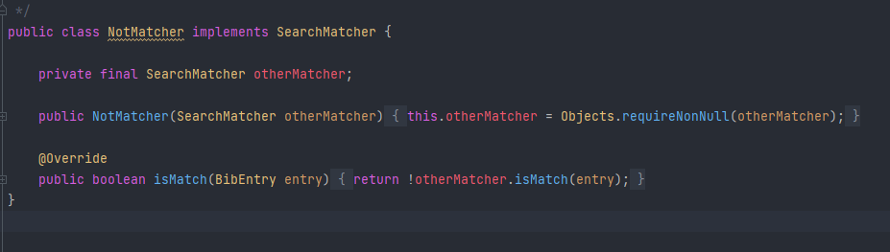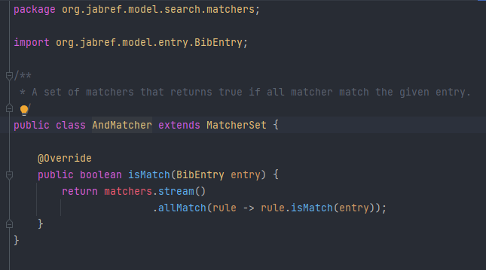

D:\IntelliJ IDEA Community Edition 2021.2.2\SE2122_54605_55355_55921_56726_57719\src\main\java\org\jabref\model\search\matchers\MatcherSet.java

We can see a Template Method Pattern, because the subclasses have the same method implemented in different ways.

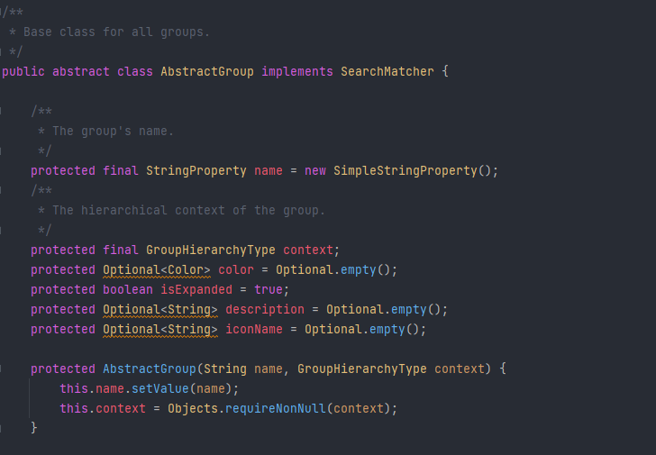

D:\IntelliJ IDEA Community Edition 2021.2.2\SE2122_54605_55355_55921_56726_57719\src\main\java\org\jabref\model\groups\AbstractGroup.java

Façade Pattern, contains and change all the information about groups. The creation of different groups and different methods.